# **The Wonders of the Philippine Tomato Industry: A Case Study on the**

**Process of Raw Material into Waste**

**Submitted by:**

Henson, Francis Luis M.

Nieves, Reymark Earl S.

Riparip, Jerome G.

Soria, Melvin Joseph B.

**Bachelor of Science in Environmental Science**

**Submitted to:**

Noel Angelo D. Binuya

**Faculty Lecturer**

**Department of Environmental Science**

**December 2024**

# Executive Summary

The Philippine Tomato Industry, which is known in the Philippines as “Kamatis” is a versatile vegetable making it a nutritious food source for every Filipino, and profitable crop that can be turned into other products such as the famous sauce which is “ketchup”. Farmers plant this crop for off-season, preferably from May to September. Due to its nature and contents, tomato can be eaten raw, cooked, or processed into a sauce/juice/jam. Tomato has two major nutrients such as Vitamin A and C. It also contains a significant amount of dietary fiber, beta carotene, iron, magnesium, niacin, potassium, phosphorus, riboflavin, lycopene, and thiamine. It is rich in lycopene and antioxidants which destroys cancer-causing free radicals in the body. Tomato is a natural antiseptic. It improves the skin and purifies the blood. It also helps cure cases of gout, rheumatism, tuberculosis, high blood pressure, and sinus trouble. As tomatoes gained more popularity in the long-run, multiple chefs and household cooks have invented various recipes on how to utilize the special characteristics of tomato making it one of the most sought-out vegetables in every nation. Being introduced in the south east asia by spanish colonials, the traditional cooking of Filipinos greatly changed which makes it engraved in each generation to demand tomatoes in their household ingredients. By the present time, Philippine Tomato Industry is still one of the leading markets due to multiple demands of both companies involved in the production of tomatoes as well as individuals needing tomatoes for their own choices.

This case study will tackle multiple problems, key issues, goals, and processes that shapes the whole Philippine tomato industry into what it is known in the present day. Additionally, some assumptions, data analysis and computations will be presented in this case study to explain the problems and improvements of the Philippine tomato industry.

# Introduction

It is almost hard to imagine tomatoes (*Lycopersicon esculentum*) growing in the wild because they have been on our menus and in our gardens for so long. Hundreds of years ago, long before Europeans had set foot in the New World, tomatoes grew wild in the Andes of Western South America. The indigenous people cultivated them, eventually bringing the plant northward through Central America and into Mexico *(A History of Tomatoes, n.d.).* Following the conquest of Mexico by Hernán Cortés in 1519, tomatoes were introduced into Spain. The Spanish distributed the tomato throughout their colonies in the Caribbean. They also took it to the Philippines, from where it spread to Southeast Asia and then the entire Asian continent *(Cabansag, n.d.).*

With various environmental and social problems arising in the modern world, the global tomato industry is being affected (*Howarth, n.d)* in terms of production, demand and its characteristics (Bhandari, Neupane, & Adhikari, 2021). Research shows that tomatoes are being produced in a large quantity with a whopping total of 187 million metric tonnes in 2020 for both processing and fresh consumption (*Branthôme, 2022)*.

In The Philippines, the tomato industry plays a significant role in the country’s agricultural landscape, serving as a vital source of livelihood for farmers and a key ingredient in Filipino cuisine. Tomato is one of the most profitable crops in the Philippines and is extensively cultivated throughout the world. However, because of inefficiencies in the stages of production, distribution and processing a significant amount of raw tomatoes are wasted despite the industry's potential *(Osuagwu, Okwulehie, Njoku, Amadi, & Onyia, 2019).* This case study explores the mechanisms that turn this amazing fruit from raw material into possible waste, delving into the tomato's intriguing journey in the Philippine context. It looks at the difficulties that stakeholders confront, such as over output, poor post-harvest procedures, and restricted access to effective facilities for processing and storage. The study also clarifies the economic and environmental effects of tomato waste, providing a critical viewpoint on how poor management affects rural livelihoods and the sustainability of the country's agriculture.

By addressing these challenges, this study aspires to contribute to a more efficient agricultural ecosystem, where tomatoes are not only celebrated for their culinary contributions but also for their role in advancing food security and environmental conservation.

# **Problems, Key Issues, and Goals**

## **Problems**

### 1. Post-Harvest Losses

This occurs due to improper harvesting, storage, handling, or transport of tomatoes.

### 2. Overproduction and Market Glut

Other farmers grow more tomatoes than the market can absorb, leading to surplus supply and a drop in market prices.

### 3. Limited Processing Facilities

Some Philippine business that causes supply chain bottlenecks is the absence of adequate or easily accessible equipment for processing tomatoes into goods like ketchup, juice, or paste.

### 4. Inefficient Supply Chain

Poor transportation networks, insufficient cold storage, or delays in getting tomatoes from fields to markets or processing facilities can all lead to supply chain inefficiencies.

### 5. Environmental Impact

The leftovers from rotten or unsold tomatoes frequently wind up in landfills, where they break down and release greenhouse gasses like methane. These practices will damage ecosystems and exacerbate the agricultural industry's sustainability issues.

## Key Issues

### 1. Economic Losses

Financial setbacks caused by post-harvest losses, inefficient production methods, and low market prices for tomatoes, reducing profitability for farmers and other stakeholders.

### 2. Food Security

The inefficiencies within the industry restrict the availability and affordability of tomatoes, which are vital to the local diet, jeopardizing stable food supplies for communities.

### 3. Sustainability Challenges

An over-dependence on traditional farming practices, resource depletion, and environmental issues such as soil degradation and waste mismanagement are obstructing long-term productivity and resilience.

### 4. Lack of Innovation

The limited use of modern technologies, including advanced farming techniques, processing methods, and value-adding strategies, hampers the industry's growth and competitiveness

### 5. Policy Gaps

Weak or inadequate government regulations, support programs, and infrastructure investments do not effectively tackle critical issues like market access, funding, and industry development.

## Goals

The goal of this case study is to identify the problems facing the Philippine tomato industry and suggest viable solutions to cut waste, boost value-added processing and boost production and supply chain efficiency. This includes addressing economic, environmental, and social impacts while fostering innovation and policy support to ensure a resilient and profitable tomato industry in the philippines.

# Decision Criteria

### 1. Land Areas

Tomatoes are one of the valued fruit products in the Philippines and they come from different regions especially from cold places or lowlands with good quality of soils that are compatible for plantation for better production which leads to a high demand.

### 2. Water Supply

One of the most important things when it comes from farming like tomato plantations is water; if it has a water supply efficiently and some practices like creating irrigation or the water pumps, tomatoes will not dry up due to the weather since tomatoes require a lot of water supply.

### 3. Impact from Environment

Since Tomatoes are harvested in the dry season, the other implication that may cause high and low demand for the product is climate. Since it has a different location of harvesting, if the place has very high temperature, it will cause drought; if the place has very low temperature, the growth of the plant will halt. Overall, the environment in which it was planted affects the growth of plants leading to the loss of productivity for the plant industry.

### 4. Fertilizer and Pest Control

Using pesticides has a two side effects for the plants, the positive effects are to avoid the insect as one of the major problem that considered as pest to kill and prevent damages to the fruits and the negative effect are the soils can be mixed with strong chemical that might affects the growth of the plant nor it will lead to soil contamination which may cause harm to various organisms.

### 5. Climate Causes

The changing of climate such as global warming can affect the way tropical cyclones are produced. We can observe that in 2024, more than 5 tropical cyclones affected the whole Philippines leading to agricultural destruction. Due to this, the production of tomatoes has led to lower demand because of rotten/damaged ones.

### 6. Transportation and Road Conflict

Deliveries of tomatoes are very crucial when it comes from different regions because of their geographic location, some of the problems are lack of transportation that delays deliveries of product, another problem is road infrastructure; national roads are always full of traffic because it is used a lot for transportation routes.

### 7. International Trading Product

Globalization has a massive impact on importing and exporting products overseas. The advantages of export are to earn more income from different countries and a high value in the market and the disadvantages of export is that we need to value our own product and have high prices from the market.

### 8. Pollution

Pollution is one of the largest problem because of the risk that affect the production such as land pollution that affect soils for poor growth, water pollution affects water supply such as irrigation and it contaminated and air pollutions like factories, transportation engines,etc., that releasing too much carbon dioxides and cause of health issues for farmers.

# Assumptions

### 1. Local Producers of Source Product

Baguio City of Northern Luzon and Bukidnon in Mindanao and other cold regions that produce tomatoes and other varieties also grown in low land areas like Ilocos, Quezon Province, Nueva Ecija, Batangas and other Provinces.

### 2. Crops and Agricultural Harvesting

Tomatoes (kamatis) are one of the famous and profitable crops that are used as ingredients for cooking in the Philippines. The popular plantations are in places with cold temperatures. The season harvesting crops preferably are during the month of May until September and considered as a hot weathered crop. This period is part of the dry season, which is more conducive for tomato growth due to the availability of sufficient sunlight and lower chances of excessive rainfall that could damage the fruit. Tomatoes are sensitive to waterlogging and fungal diseases that can occur during the wet season, so the dry months are generally more favorable for tomato cultivation in the country.

### 3. Demand-Driven Cost

According to Philippine Statistic Authority (PSA), the average production harvest of tomatoes are at 28,832.93 kilograms per hectare, gross returns reached Php 329,914.77 per hectare, return above cash cost averaging Php 178.805.10 per hectare, return cash and not-cashed cost are computed at Php 178,532.24. Net returns average Php 135,438.21 per hectare. Farmers netted at Php 0.70 per every peso invested in tomato production.

### 4. Overproduction Leads to Discarding of Tomatoes

During the month of May to September, harvesting of tomatoes are being initiated simultaneously in every corner of the country and because of this, the supply of tomatoes in the market increases drastically leading to a lower demand. Most of the tomatoes that were not sold or rotted are discarded, making a lot of waste rather than turning them into useful products such as fodder or fertilizer.

### 5. Health Product Benefits

Consuming tomato products as the proportion of plant food in the diet increases, such as healthy development for heart disease decreases, diabetes, cancer. This fruit consumes vitamin A, Vitamin C, folic acid, a wide array of nutrients and antioxidants that are linked into healthy skin, hair, weight loss and high energy.

# 

# 

# Data Analysis and Computations

**Figure 1. Production Volume of Tomatoes in the Philippines from 2012 to 2023**

**(in 1,000 metric tons) (Source: SEARCA, 2022)**

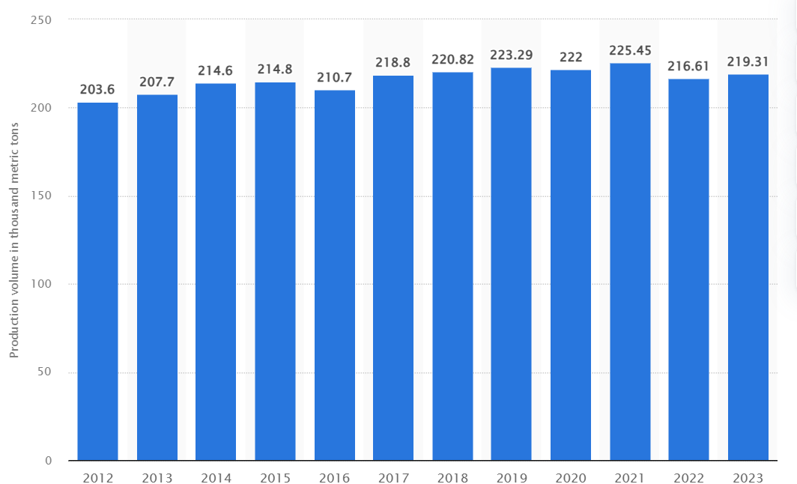

**Average Tomato Production:** 216.47 tons of tomato

**Maximum Tomato Produced in a Year:** 225.45 tons (2021)

**Minimum Tomato Produced in a Year:** 203.6 tons (2012)

**Standard Deviation:** 6.53

**Figure 4. Factors Affecting Post-Harvest Losses (Source: SEARCA, 2022)**

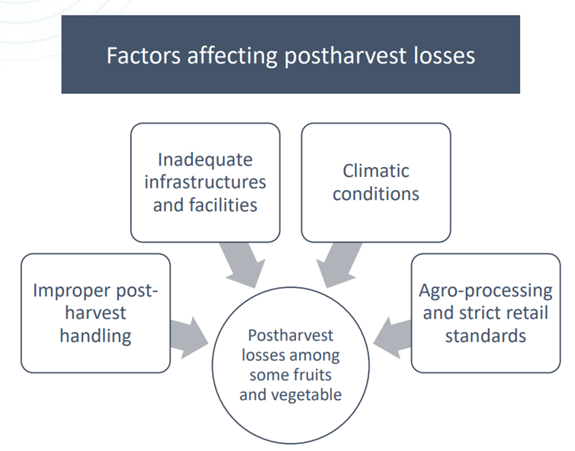

**Post-Harvest Loss of Tomatoes in the Philippines**

**Figure 5: Place of Trade (Source: Baticados, 2022)**

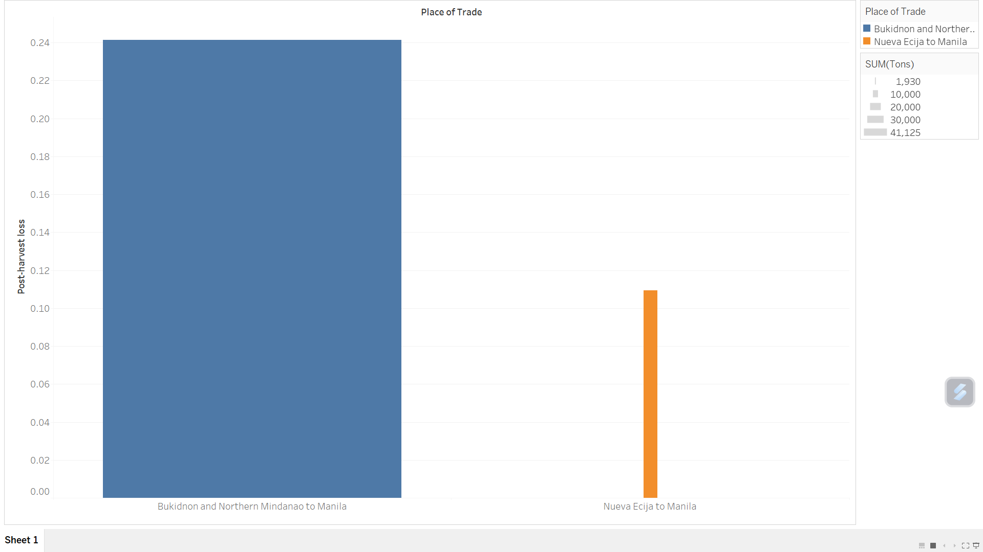

**Nueva Ecija to Manila Loss Percentage =** 10.94%

**Nueva Ecija to Manila Loss Tons =** 1,930 tons

**Loss Value =** Php 47,000, 000

**Bukidnon and Northern Mindanao to Manila Loss Percentage =** 24.14%

**Bukidnon and Northern Mindanao to Manila Loss Tons =** 41,124 tons

**Loss Value =** Php 180, 000, 000

**Figure 6. Difference between Post-Harvest and Post-Harvest Loss**

**(Source: SEARCA, 2022)**

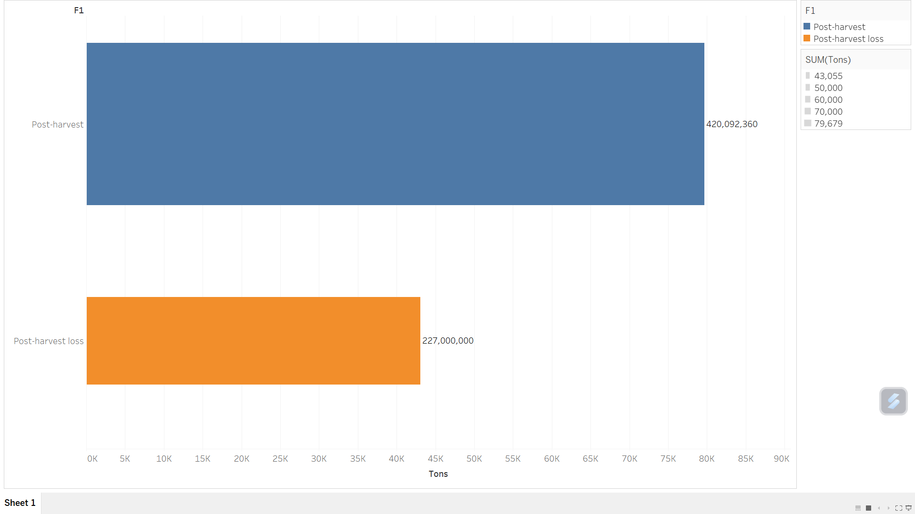

**Total Post-Harvest Loss Percentage =** 35.08%

**Total Loss Tons =** 43,054 tons

**Total Loss Value =** Php 227, 000, 000

**Successful Post-Harvest Percentage =** 64.92%

**Tons =** 79,678.751 tons

**Value =** Php 420,092,360.319

# Illustrations

**Figure 8. Post-Harvest Losses of Tomato (Source: Baticados, 2022)**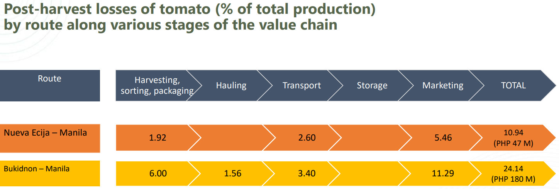

**Figure 9. Availability and Quality of Support Facilities: Tomato (Source: Baticados, 2022)**

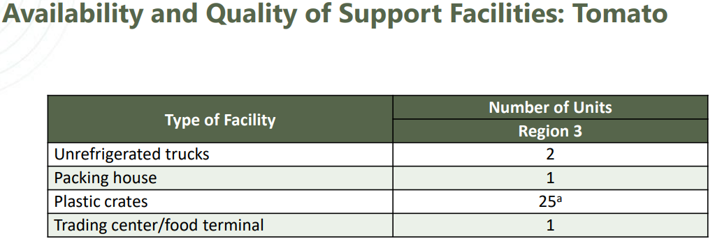

# Recommendation

The post-harvest of tomatoes is one of the negative impacts that can cause market failure in the Philippines, whereas; improper harvesting, storage, handling, and transport of tomatoes will impact the quality leading to low demand that will contribute to additional waste that are being thrown out to the landfills causing the increase of greenhouse gasses released from these rotten tomatoes.

By adapting the methods presented in the study entitled “Reducing Post-Harvest Losses in Tomatoes” by [Obekpa](https://www.researchgate.net/profile/Hephzibah-Obekpa?_tp=eyJjb250ZXh0Ijp7ImZpcnN0UGFnZSI6InB1YmxpY2F0aW9uIiwicGFnZSI6InB1YmxpY2F0aW9uIn19), H.O. (2019, May) such as the accessed of different improved varieties of tomato seeds that have longer shelf life compared to normal so as to avoid the increase of waste leading to increased greenhouse gases. Additionally, to reduce post-harvest losses considerably, she added that logistic control activities as well as the support of extension agent and private tomato processing firms must come into action for an efficient coordination between the local farmers and the firms that are actually acquiring them to process for other products such as tomato ketchup and more.

The researchers would also like to add a recommendation that a proper seminar on the handling of tomatoes and coordination between tomato farmers should be the focus of the government in the Philippines as to avoid the increasing of the production that will have a huge impact on the demand of the tomatoes in which higher supply will yield a lower demand leading to the spoilage and throwing of the excess tomatoes in a landfill causing the increase of greenhouse gases that warms up our planet that affects millions of living organisms.

# Conclusion

The Philippine tomato industry is one of the leading industries that provides the sought-out vegetable in every Filipino cuisine. With various factors presented in this case study, the researchers deduced that the tomato industry is facing various problems and issues, specifically the farmers that harvested them. One of the problems that the researchers identified is the lack of innovation compared to developed countries such as U.S.A. and Australia wherein they use automated harvesting systems and proper policies to support their farmers, which increase efficiency and reduce post-harvest losses compared to the Philippines, most Filipino farmers rely on traditional farming such as the use of their own hands to plant and harvest each tomato making the process much longer. Additionally, the lack of proper knowledge of transportation networks, insufficient cold storage, or delays in getting the tomatoes from the fields to the market or processing facilities leads to supply chain inefficiencies that contribute to tomatoes turning into waste.

With the data from SEARCA, 2022 presented in the data analysis, we can observe that the total post-harvest is 64.92% (approximately 79,679 tons) valued at approximately ₱420.09 million, while the remaining percentage of 35.08% (approximately 43,055) valued at ₱227 million at loss. This result indicates that the Philippine Tomato industry represented by the three provinces: Nueva Ecija trading with Manila; Bukidnon and; Northern Mindanao experienced these post-harvest losses yearly which led to some farmers having a hard time sustaining their income.

Moreover, lack of proper policy intervention from our government and communication in the Tomato industry from multiple companies involved makes overproduction and market glut leading to surplus of supply and a drop in market price wherein the tomatoes that goes rotten or damage due to improper storage are being thrown in landfills contributing to the release of greenhouse gases that affects the global climate change whole wide. If these practices continue, the tomato industry will struggle to achieve sustainability, causing financial hardships for farmers and contributing to environmental degradation.

# References

Cabansag, K. (n.d.). TOMATO INDUSTRY CASE STUDY. Scribd. <https://www.scribd.com/document>

Baticados, G.N. (2022, November 23-24). Opportunities and strategies to reduce postharvest losses of horticultural crops: The Case of the Philippines. SEARCA. Retrieved from https://events.development.asia/system/files/materials/2022/11/202211-opportunities-and-strategies-reduce-postharvest-losses-horticultural-crops-case-philippines.pdf?fbclid=IwZXh0bgNhZW0CMTAAAR0lX5PJsjHEGEbft7r9AM96VeQSIgUyntRSP0WQ9iR_a_2nscaQJIkUgE0_aem_ltQUvvTJ6CD7YuYUDXlMJA

SEARCA (2022, March 21). Study bares huge post-harvest losses. Retrieved from <https://www.searca.org/press/study-bares-huge-post-harvest-losses>